Assignment - 3

1. Distinguish between man and whatis commands? Justify with proper example.

Answer->

| **man command** | **whatis command** |
| --- | --- |
| Displaces the complete manual of command | Shows the breaf description |
| May include multiple sections like name ,description | Concise and summary-like; only the command name and a short description. |
| Useful when u want to learn all about particular command | Useful when you want a **quick reminder** of what a command does. |
| man [command_name] | whatis [command_name] |
| man -ls ,shows the full manual of ls commands | Whatis shows like ,ls (1) - list directory contents |

* ┌──(kumya㉿sonic)-[~]

└─$ man ls

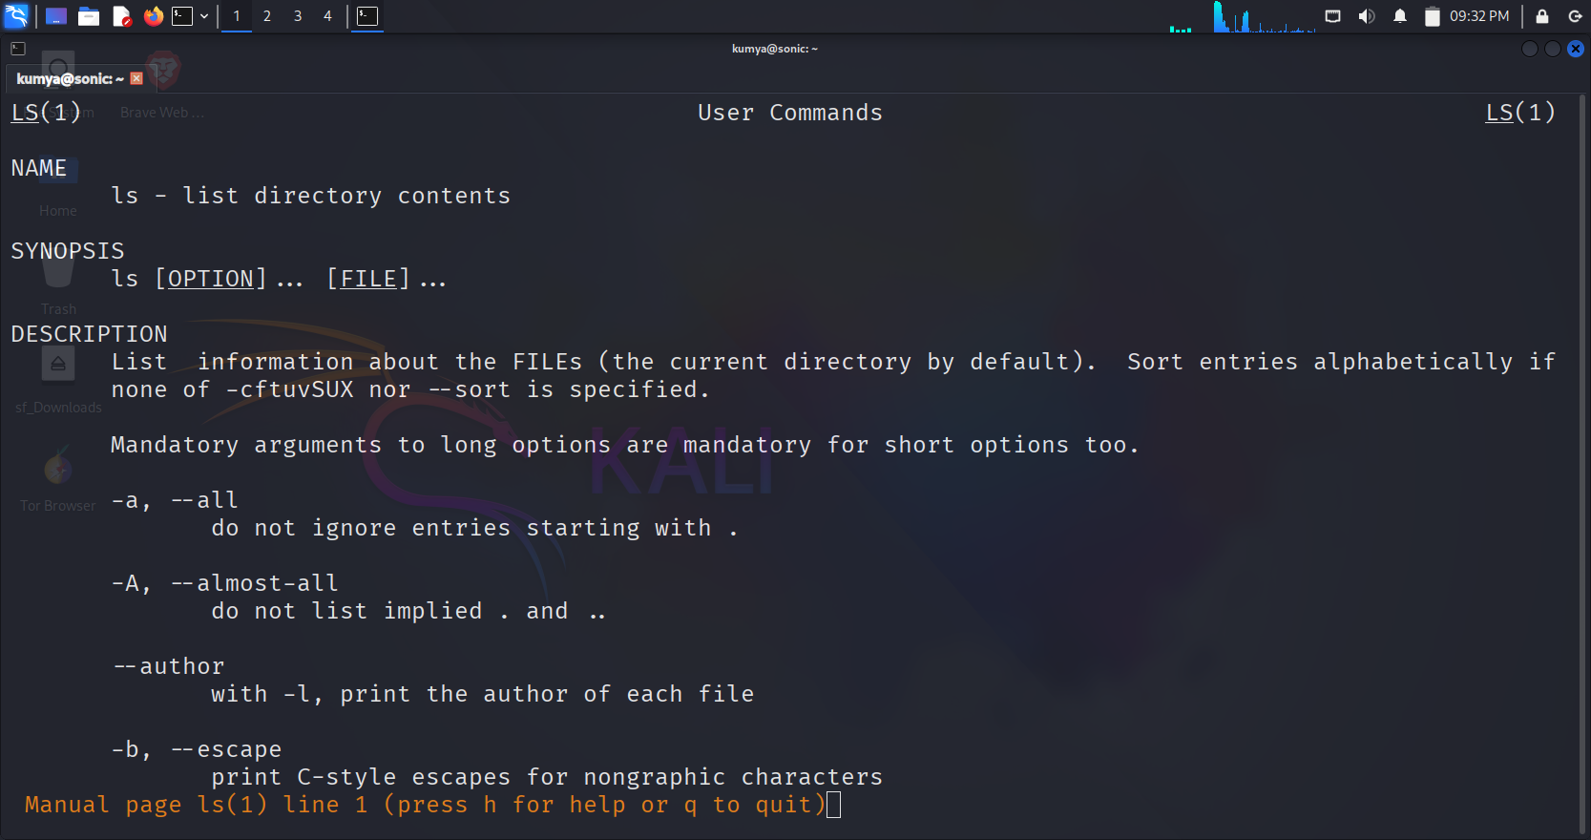

* ┌──(kumya㉿sonic)-[~]

└─$ whois ls

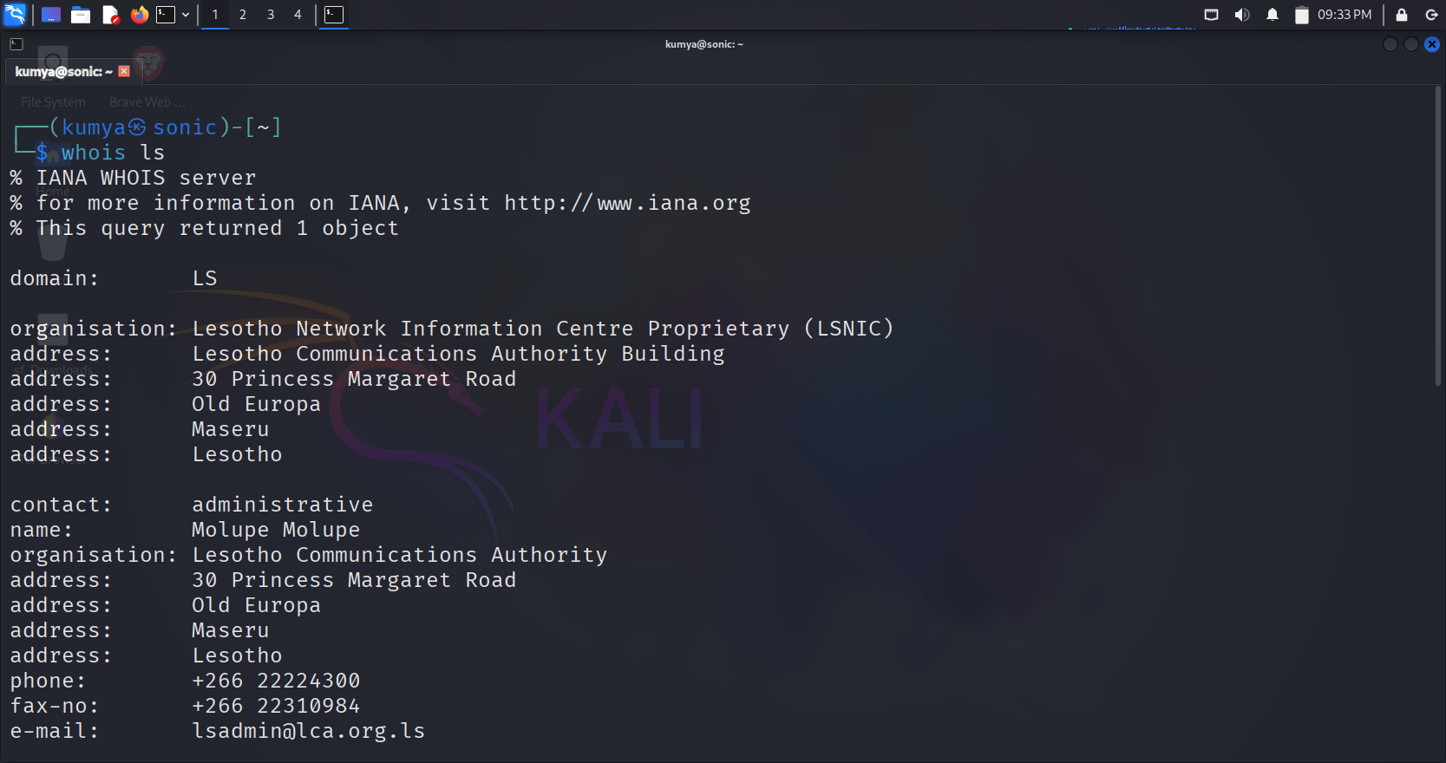

1. Use the tee command to save the output of ls -l into a file while also displaying

Answer->

ls -l -> lists the file in long format.

Tee -> tee command reads the standard input and writes the standard output on screen and saves it in file

* ┌──(kumya㉿sonic)-[~]

└─$ ls -l | tee file1.txt

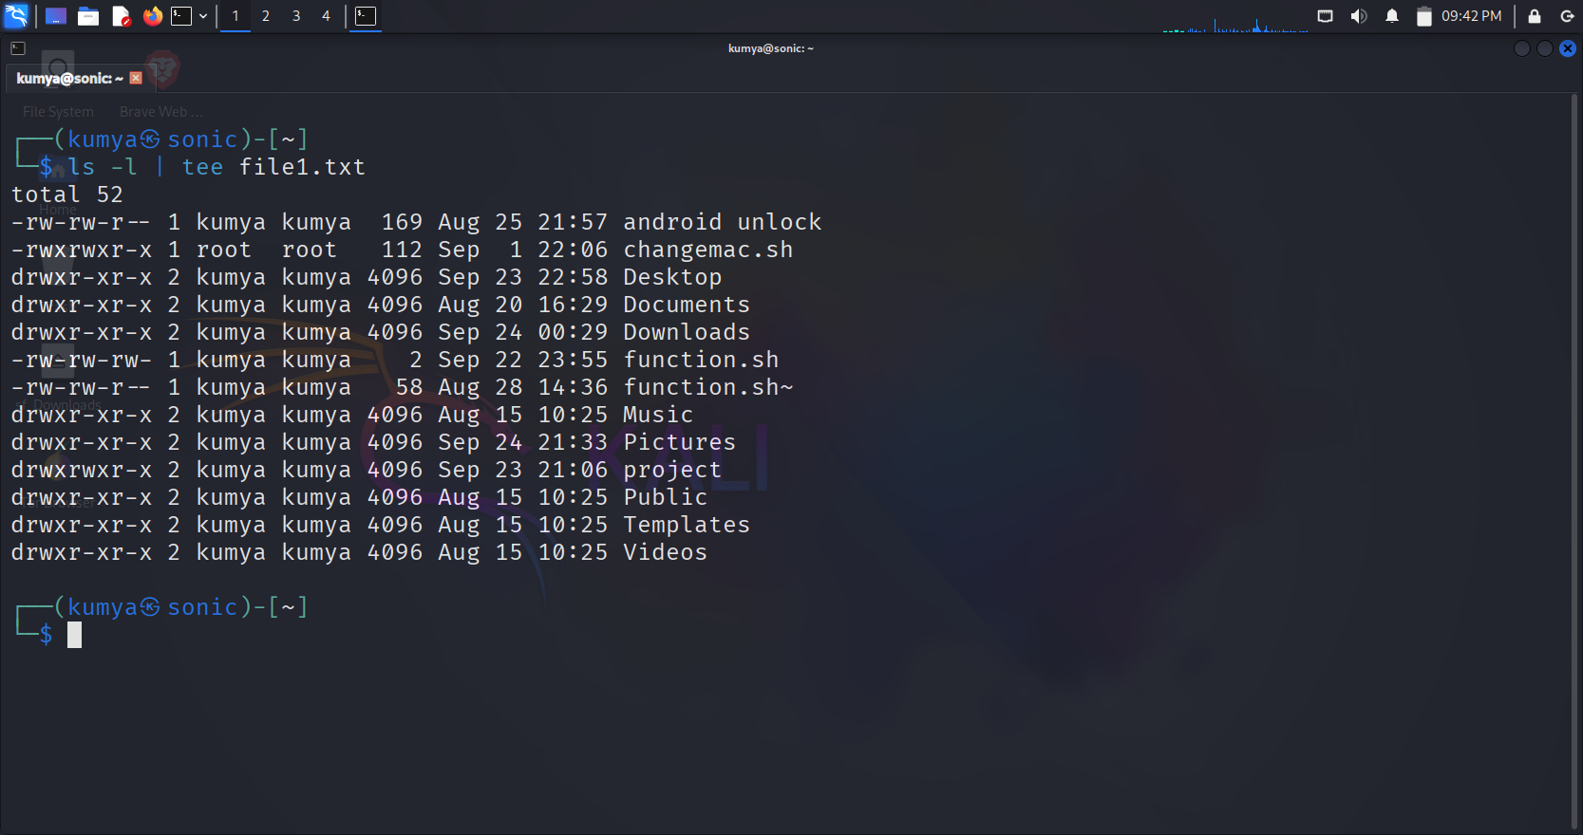

1. Explain with an example how the tee command can be used in logging ?

Answer->

* The tee command is preferred because one it displays on screen and other it saves to file
* When we run a tee command it produces lots of output. And creates update.log fine and updates all the newly installed packages
* ┌──(kumya㉿sonic)-[~]

└─$ sudo apt-get update | tee update.log

1. List the steps involved in installing Ubuntu 25.04 LTS on Oracle VirtualBox ?

Answer->

1. Install virtual box on host machine from a virtual box website and the extensions of it also
2. Download ubuntu 25.04 from ubuntu website.
3. Make sure your system has minimum amount of space for operating system to install of 4 GB RAM and 25 GB of disk space and enough CPU core
4. Open virtual box, click on new and give a name as Linux and give a path of file that where a file is stored
5. Next set a RAM as 4 GB and disk space as 25 -30 GB and then allocate number of CPUs 2 or more than 2
6. Then attach the IOS file of ubuntu, then go to the ubuntu installation
7. Give a Sudo apt update and upgrade command so that it can download all the packages

5) During Ubuntu OS installation, you face a Kernel Panic Error. How would you troubleshoot it?

Answer->

1. Check the IOS file make sure that ubuntu IOS file is not corrupted
2. Check the virtual machine , make sure that you selected correct IOS file
3. Boot with safe ,edit boot parameters or try safe graphics which shows while installing ubuntu
4. Check hardware compatibility ,some newer hardware need newer kernels
5. Disable problematic devices ,like USBs completely remove it from the system
6. Test ram and disk which are correct or not that minimum space is given or not .
7. Examine the panic message given by the operating system .
8. At last to fix it we can run a code that updates and upgrades the system.
9. Write the command to display the system’s hostname? How to change hostname using sysctl command ?

Answer->

* ┌──(kumya㉿sonic)-[~]

└─$ hostname

Sonic

* ┌──(kumya㉿sonic)-[~]

└─$ sudo hostnamectl set-hostname leo

* This sets net hostname to leo
* ┌──(kumya㉿leo)-[~]

└─$ hostname

Leo

7) Which command is used to show the calendar of the year 1984 with August month?

Answer->

* ┌──(kumya㉿sonic)-[~]

└─$ cal 8 1984

⁕ **cal** → Displays a calendar.

⁕ **8** → Month number (August).

8) Write a command to display system uptime and logged-in users together ?

Answer->

* You can use
* ┌──(kumya㉿sonic)-[~]

└─$ uptime; who

Shows how long the system is running and how has been loged in.

* ┌──(kumya㉿sonic)-[~]

└─$ w

22:42:47 up 1:11, 1 user, load average: 0.23, 0.22, 0.18

USER TTY FROM LOGIN@ IDLE JCPU PCPU WHAT

kumya - 21:31 0.00s 0.03s lightdm --session-child 13 24

* Shows the same information

9) Use the find command to list all “.c” files in /home/user ?

Answer->

* ┌──(kumya㉿sonic)-[~]

└─$find /home/kumya -type f -file1 "*.c"

* Gives a output as

/home/kumya/program1.c

/home/kumya/projects/test.c

/home/kumya/code/hello.c

10) How do you change file permissions to allow only the owner to read and write?

Answer->

* ┌──(kumya㉿sonic)-[~]

└─$chmod 600 filename

⁕ **chmod** → Change file permissions.

⁕ **600** → Sets permissions as follows:

⁕ 6 → Owner can **read (4) + write (2) = 6**

⁕ 0 → Group has **no permissions**

⁕ 0 → Others have **no permissions**

* ┌──(kumya㉿sonic)-[~]

└─$chmod 777 file1.txt

⁕ gives full permission to owner.